Chapter 7 The Internet Protocol V4
IP协议的主要任务是隐藏各种链路层之间的差异，并且为不同的网络技术提供统一的表示。IP协议的关键点在于Routing和Fragmentation。
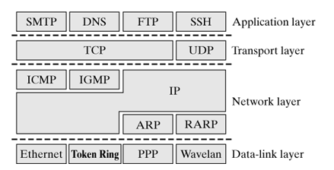
In summary, the Internet Protocol handles the following functions:
- provides an unsecured connectionless datagram service;
- defines IP datagram as basic units for data transmission;
- defines the IP addressing scheme;
- routes and forwards IP datagram across interconnected networks;
- verifies the lifetime of packets(TTL);
- fragments and reassembles packets;
- Uses ICMP to output errors.

7.1 Brief introduction
Internet是由多个局域网连接起来的网络，局域网之间由路由器连接。(在一个网络内部，通常要求构建多个sub-networks，网络和子网之间都是由路由器或是点到点线路相互连通的)：
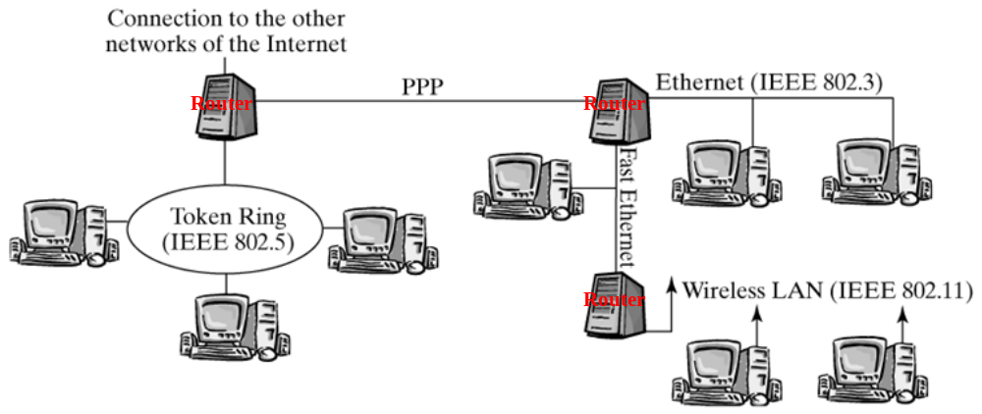
The interconnection of single local area networks offers a way to send data from an arbitrary computer to any other computer within the internetwork. Before it sends a packet, an Internet computer checks for whether the destination computer is in the same local area network. If this is not the case, then the data packet is forwarded to the next router. If both the sender and the receiver are in the same local area network, then the packet is delivered to the receiver directly over the physical medium. In either case, the IP layer uses the service of the data-link layer to physically transport the packet.
Let's assume that, in the first case, the packet has not yet arrived in the destination computer. The router checks the destination address in the IP packet header and the information in the routing table to determine how the packet should be forwarded. Next, the packet travels from one router to the next until it eventually arrives in the destination computer.
IP Header的结构参见附录B。
特殊的IP地址归总：
注：。子网号栏为空表示该地址没有进行子网划分。
IP Address |  |  |  |  | Description
网络号 | 子网号 | 主机号 | 源地址 | 目标地址
0 |  | 0 | √ | × | 本主机的IP地址
0 |  | hostid | √ | × | 本地网络上的特定主机IP地址
127 |  | anything | √ | √ | 环回地址
-1 |  | -1 | × | √ | 受限的广播(永远不被转发)
netid |  | -1 | × | √ | 以网络为目的向netid广播
netid | subnetid | -1 | × | √ | 以子网为目的向netid中的subnetid广播
netid | -1 | -1 | × | √ | 以所有子网为目的向netid广播

7.2 Implementing the Internet Protocol
一个Packet(sk_buff)有三种方式进入IP层：
- Packets arriving in a computer over a network adapter are stored in the input queue of the respective CPU, Once the layer-3 protocol in the data-link layer has been determined (which is ETH_P_IP in this case), the packets are passed to the ip_rcv() function. 这是receiving packet流进IP层的情况。
- The second entry point for IP packets is at the interface to the transport protocols. These are packets used by TCP, UDP, and other protocols that use the IP protocol. They use the ip_queue_xmit() function to pack a transport-layer PDU into an IP packet and send it. Other functions are available to generate IP packets at the boundary with the transport layer. 这是Sending Packet从传输层流进IP层的情况。
- With the third option, the IP layer generates IP packets itself, on the Internet Protocol's initiative. These are mainly new multicast packets, new fragments of a large packet, and ICMP or IGMP packets that don't include a special payload. Such packets are created by specific methods (e.g., icmp_send()). 这是IP层自己生成IP Packet的情况，比如分片或是ICMP/IGMP包。
补充资料：
实现IP协议的系统可以分成2类：
- End system: A Linux computer is normally configured as an end system—it is used as a workstation or server, assuming primarily the task of running user applications or providing application services. Also, a Web server and a network printer are nothing but end systems (with regard to the IP layer). The basic property of end systems is that they do not forward IP packets. This means that you can recognize an end system easily by the fact that it has only one network adapter. Even a system that has several network accesses can be configured as a host, if packet forwarding is disabled.
- Router: A router passes IP packets arriving in a network adapter to a second network adapter. This means that a router has several network adapters that forward packets between these interfaces. When packets arrive in a router, there are generally two options: they can deliver packets locally (i.e., deliver them to the transport layer) or they can forward them. The first case is identical with the procedure of packets arriving in an end system, where packets are always delivered locally. Consequently, a router can be thought of as a generalization of an end system, with the additional capability of forwarding packets. In contrast to end systems, generally no applications are started in routers, to ensure that packets can be forwarded as fast as possible.
下面就Packet进入IP层的三条路线分别阐述。
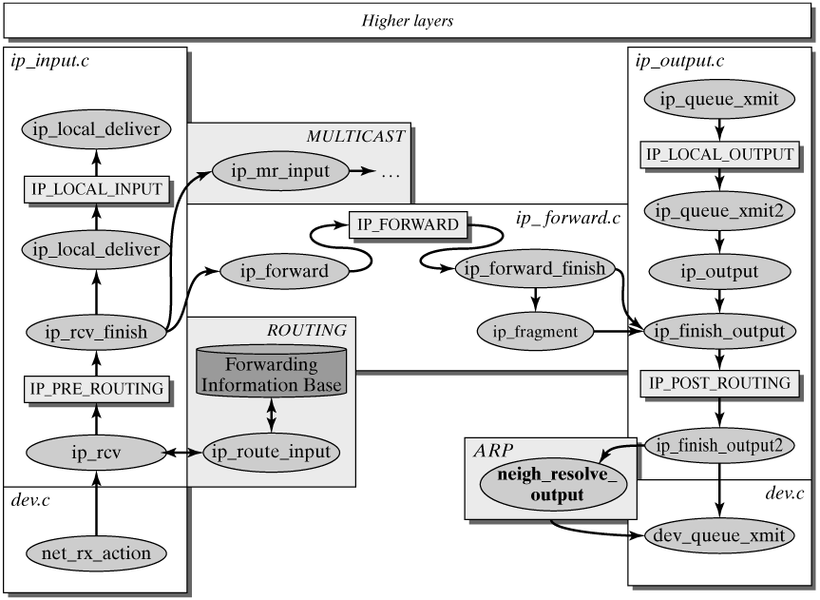

7.2.1 The Path of Incoming IP Packets
这是第一种路径，即receiving packet流进IP层。entry point是ip_rcv().
ip_rcv()流程：
1) 首先它检查收包的网络适配器是否处于混杂模式，即包的目的MAC地址不是本机，若是，则drop该包：
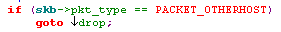
2) 接着它会检查Packet中的IP Header，具体来说，IP Header中的IHL字段，version字段，总长度字段以及Header 校验和字段，如果它们中的一个发生错误，则Drop该Packet。
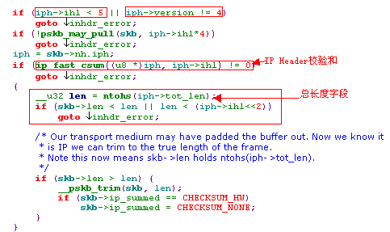
3) 如果上述检查通过，则会调用名为NF_IP_PRE_ROUTING 的Netfilter Hook：
注：Netfilter allows you to extend the procedure of various protocols by specific functions, if desired. Netfilter hooks always reside in strategic points of certain protocols and are used, for example, for firewall, QoS, and address-translation functions.
4) 如果没有配置NF_IP_PRE_ROUTING的netfilter，则会调用ip_rcv_finish().即若nf_hooks[PF_INET][NF_IP_PRE_ROUTING]链表为空，则调用ip_rcv_finish().
ip_rcv_finish()流程：
1) 首先检查sk_buff的dst字段是否为空，dst字段指向一个dst_entry结构，如果为空，则调用ip_route_input()填充该结构，它主要填充input字段。这是IP层的路由功能，该字段就是该包的路由信息。
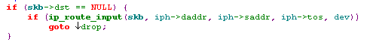
dst_entry结构记录着该Packet的Further Path，主要记住三个字段：
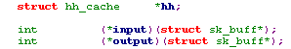
这个Packet可能是deliver给本地计算机的单播/多播包，也可能是广播包，又或者是需要转发的单播包，又或者是需要转发的多播包。根据这些不同的情况，input被赋予不同的函数：
- ip_local_deliver() is entered in the case of unicast , broadcast and multicast packets that should be delivered to the local computer.
- ip_forward() handles all unicast packets that should be forwarded.
- ip_mr_input() is used for multicast packets that should be forwarded.

2) 判断IP Header中是否含有Options，如果有，则将它们存储到一个ip_options的结构中：
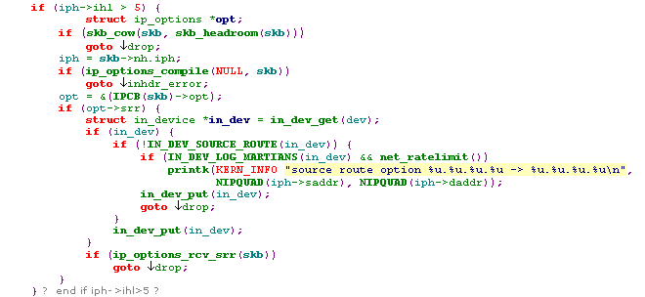
3) 如果IP Header存在Source Route Option(strict Or loose)，若存在，则调用ip_options_rcv_srr(skb)处理source route option：
  - 如果本机IP等于IP Header中的目的地址，且指针不大于路径的长度，那么(1)由p t r所指定的清单中的下一个地址就是数据报的最终目的地址；(2)由外出接口(outgoing interface)相对应的I P地址取代刚才使用的源地址；(3)指针加4， (4）重新根据最新的目的地址，重新调用ip_route_input()计算路由；
  - 否则，什么也不干。
4) 调用skb->dst->input()函数：
① 当input被设置为ip_forward()时，表示该Packet为需要转发的单播包。
ip_forward()流程:
1) 首先检查该Packet为单播包，即skb->pkt_type为PACKET_HOST，否则drop该包：
2) 检查IP Option中strict source route option：
如果是loose source route option，就不会做这种检查。
检查不通过，就会drop packet。
3) 检查该包的转发次数是否过多。还记得IP Header的TTL字段吗？如果此时它的值小于等于1，则表示该包生存期已经Over，这时会Drop该包，并向发送方发送一个ICMP包(ICMP_TIME_EXCEEDED)作为通知:
4) 否则，将IP Header的TTL字段递减1。
5) 查看是否需要分片。如果当前Packet的中长度大于链路层的MTU且IP Header中设置了DF标志(不分片)，则Drop该包，且向发送方发送ICMP消息(ICMP_FRAG_NEEDED)。
6) 调用一个名为NF_IP_FORWARD的Netfilter Hook。它查看nf_hooks[PF_INET][ NF_IP_FORWARD]链表是否为空，如不为空，则调用相应的Hook，接着调用ip_forward_finish():
ip_forward_finish()流程:
它首先调用ip_forward_options(skb) 处理IP Header中的选项，这里主要调用ip_forward_options()处理Record Route Option, Timestamp Option。然后判断该Packet是否需要分片，如果需要则调用ip_fragment()对其分片，最后调用ip_finish_output()将分片后的包或是不需要分片的原始包发送出去。
ip_finish_output ()流程:
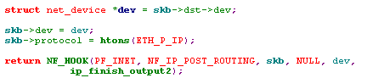
从上可以看出，它将包的dev字段设置为dst_entry中的dev字段(该字段对应将该包发送出去的物理网络适配器，它也是该包路由信息的一部分)，然后将protocol字段设置为ETH_P_IP，接着激活NF_IP_POST_ROUTING钩子，最终会调用ip_finish_output2()。
ip_finish_output2()流程：
At this point, the packet leaves the Internet Protocol, and the Address Resolution Protocol (ARP) is used, if necessary. For now, it is sufficient to understand the following:
- If the routing entry used (skb->dst) already includes a reference to the layer-2 header cache (dst->hh), then the layer-2 packet header is copied directly into the packet-data space of the socket buffer, in front of the IP packet header. The output() function used here is dev_queue_xmit(), which is invoked if the entry in the hardware header cache is valid. dev_queue_xmit() ensures that the socket buffer is sent immediately over the network device.
- If there is no entry in the hard header cache yet, then the corresponding address-resolution routine is invoked, which is normally the function neigh_resolve_output().

② 当input被设置为ip_local_deliver()时，表示该Packet为deliver给本地的单播或多播包或广播包。
ip_local_deliver()流程：
1) 调用ip_defrag(skb)组装分片后的包。For now, it is sufficient to understand that all fragments of a packet are collected over a certain period of time, until all fragments of an IP datagram have arrived, so that they can be passed upwards as a whole.
2) 调用NF_IP_LOCAL_IN钩子，处理完钩子后，再调用ip_local_deliver_finish()：
ip_local_deliver_finish()流程：
第三层协议实例主要在ptype_base散列表中(ptype_all通常没有)，而第四层协议实例主要在inet_protos散列表中，每个元素都是一个inet_protocol结构，根据协议的不同，handler字段也不同：
- tcp_v4_rcv(): Transmission Control Protocol (TCP)
- udp_rcv(): User Datagram Protocol (UDP)
- icmp_rcv(): Internet Control Message Protocol (ICMP)
- igmp_rcv(): Internet Group Management Protocol (IGMP)
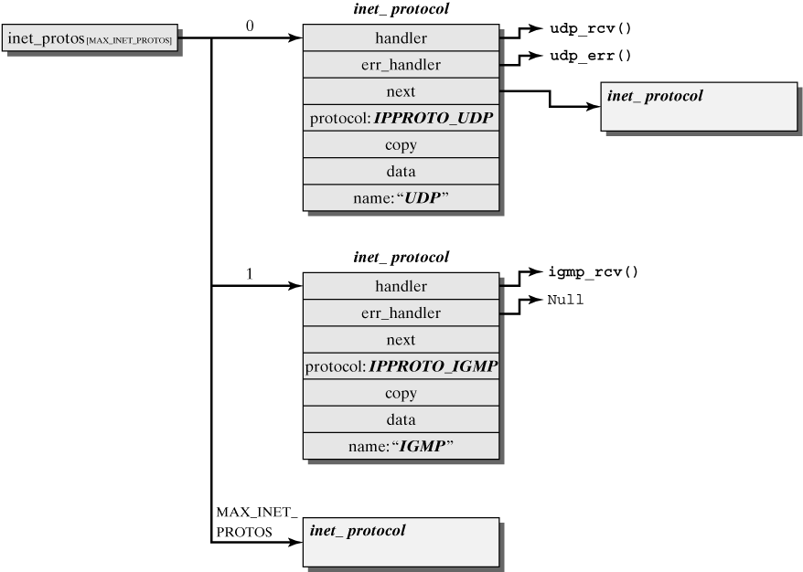
- 首先检查是否存在一个RAW-IP socket, 若有则将该包传递给该RAW-IP socket， 然后根据IP Header的protocol字段，(而不是skb结构中的protocol字段)调用相应的第四层协议实例去处理，
注：IP Header的protocol字段可能是ICMP，IGMP，UDP，TCP。
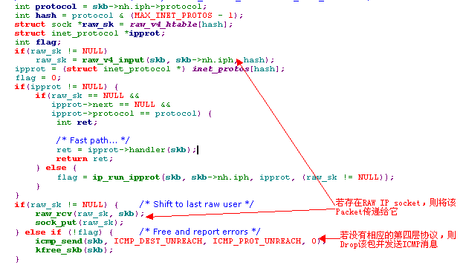
If no transport protocol can be found, then the packet either is passed to a RAW socket (if there is one) or it is dropped and an ICMP Destination Unreachable message is returned to the sender.

7.2.2 The Path of Sending IP Packet
本地创建的Packet从传输层传递到IP层，这是另一条流进IP层的路径。对传输层来说，有多个函数用于该目的：ip_queue_xmit()和ip_build_and_send_pkt().本节只讨论ip_queue_xmit()，ip_build_and_send_pkt()用于那些没有有效负荷的SYN/ACK包。
ip_queue_xmit(struct sk_buff *skb, int ipfragok)流程：
1) 本地生成的Packet都归属于一个Socket。也就是说该Socket下的所有Packet应该有相同的路由。正是这样的原因，代表Socket的数据结构struct sock中包含dst_cache字段：
这里首先检查该Packet所属Socket中指向路由信息的指针sk->dst_cache是否为空，若为空，则表示未设置路由(当套接字的第一个包Ready时)，则调用ip_route_output()设置路由。事实上它会设置dst_entry结构中的dev, output字段，将output字段设置为ip_output()。
注：对一个Socket而言，只需设置一次路由，因为该Socket的Packet都具有相同的路由。
在给socket给出路由时，要考虑Source Route Option： 将Source Route Option第一个表项作为“临时”目的地址，将其作为rt_dst，然后删除第一项，将剩余的项移到第一项中，并将原来的目的地址作为清单的最后一项。指针仍然指向清单的第1项（即，指针的值为4）。接着后面的ip_route_output()就以rt_dst为主来选择路由了。
路由选择好后，还要检查strict source route option：
2) 设置IP Header的各个字段，包括TTL，protocol, IP源地址，IP目的地址，标志位以及包总长度等:
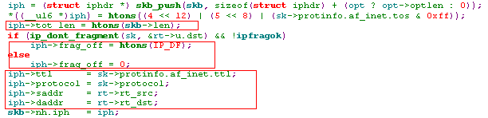
这里的iph->protocol只可能是下面3种值：对于TCP socket来说，iph->protocol为IPPROTO_TCP；对于UDP socket来说，iph->protocol为IPPROTO_UDP；对于raw socket来说，iph->protocol为NULL。
3) IP Option选项包含在Socket中，也就是说如果Socket有IP Option，该Socket下的Packet都应该有IP Option。这时会检查该Socket是否有IP Option，如果有，则调用ip_options_build()将IP Option添加到Packet的IP首部：
注：只在发送Packet时(包括转发)才会处理IP Options和必要的分片
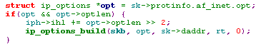
4) 激活名为NF_IP_LOCAL_OUT的Netfilter Hook，处理完该Hook，则调用ip_queue_xmit2():
ip_queue_xmit2()流程：
1) 现在路由已经确定了，即已经知道发送该Packet的物理网络适配器。这时根据连接该网络适配的网络MTU调整sk_buff的预留空间。
2) 接着检查它是否需要分片，同样，如果IP Header中DF标志没有置位且需要分片，则Drop该包并发送ICMP_FRAG_NEEDED消息。
3) 调用ip_send_check()在IP Header中添加IP首部校验和。
4) 无论分片与否，都调用skb->dst->output(), 前面说过，此时output指针设置为ip_output()：
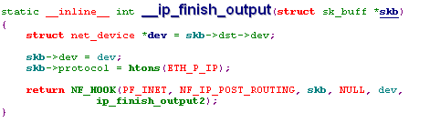
补充资料：分片
Each fragment of a split IP datagram is treated like an independent IP packet and contains a complete IP packet header. All the fragments of a datagram can take different paths to travel to the destination computer, and they may be fragmented more than once along these paths. The position of a fragment's data within the original IP datagram is marked by the Fragment Offset field. All fragments, except the last one, have the MF (More Fragments) bit set, which means that more fragments are to follow. (MF, DF等标志在IP Header中)Remember that IP packets can be fragmented in each IP node along the path to the destination (router or end system), but can be reassembled only in the destination computer.
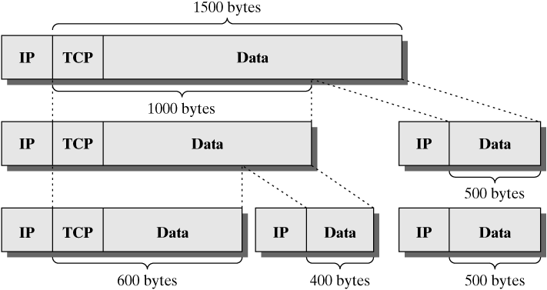
1> 分片函数ip_fragment()
First, the maximum packet size is computed, and then IP fragments are created in a while loop until the datagram has been completely divided into smaller packets. Next, alloc_skb() is used to create a new socket buffer for each new fragment. Initially, the IP packet header is copied from the original packet to the new one, and then the payload to be transported in this fragment is copied to the fragment. It should be mentioned once more that previously fragmented datagrams can be fragmented again in one or more routers later along the path. Subsequently, the new value for the Fragment Offset field has to be set in the new fragment. This field specifies the position of payload in the original IP datagram. Also, the MF bit has to be set, unless it is the last fragment. Before the output() function (pointer to the transmit function set in the routing process) can send the packet, the function ip_options_fragment() handles IP options, if present, and ip_send_check() computes the checksum.
Once all fragments have been created, the original packet is released by kfree_skb().
注：ip_fragment()会将源Packet分成若干片，且对每个分片都会调用相应的output函数将其发送出去。
2> 包的组装
Fragmented IP datagrams are reassembled in the end system only. The fragments are then managed in the fragment cache, until either all fragments of a datagram have arrived, so that the packet can be delivered to the local machine, or the maximum wait time for the fragments of a datagram (ipfrag_time, ~30 seconds) has expired, which means that the datagram will be discarded. The fragment cache consists of a hash table with ipq structures. Each of these ipq structures represents a fragmented IP datagram. The individual fragments of the datagram are collected in a linked list (fragments). All fragments of a datagram are ordered in the same sequence as they occur in the original packet:
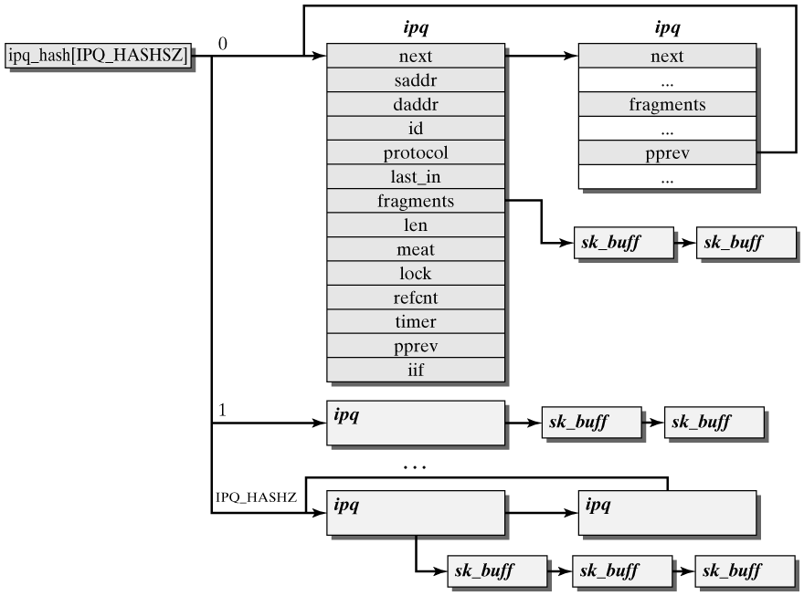
包的组装主要是由ip_defrag()负责。在ip_local_deliver()或ip_conntrack_in()中会调用它(因为只有组装后的包才能传递给上层协议或分配给一个连接)。如果包组装完毕，该函数返回组装后的sk_buff指针，否则返回NULL。ip_local_deliver()或ip_conntrack_in()都会查看该返回值，只有为非NULL时才会做进一步处理。
ip_defrag()的主要步骤是先根据该Packet包头的信息查找ipq_hash表(Hash 表)，找到相应的ipq，如果fragment hash表中没有相应的ipq，则在fragment hash表中分配一个新的ipq结构(一个ipq结构代表一个完整的IP包的fragments)，并设置一个timer，每隔30s就会调用timer-handler：ip_expire()。从接受到第一个fragment开始计时，30s后ip_expire()会检查这个IP包的fragments是否全部收到, 如果全部收到则什么也不干，直接返回，否则发送ICMP Message(ICMP_TIME_EXCEEDED)。
ip_defrag()在fragment hash中找到一个ipq结构后，将该sk_buff插入相应的ipq结构中，如果该Packet是最后一个fragment，则生成一个全新的sk_buff结构，并将ipq结构释放(包括所有fragments的sk_buff)，然后返回这个新sk_buff结构的指针。否则，将sk_buff插入完成后，返回NULL。

7.2.3 IP Instance
路由器的IP Instance的主要任务是转发IP Packet。因此一个IP Instance可以配置多个物理网络设备。下面介绍IP Instance管理这些network device的数据结构。
An in_device structure is created for each network device that was configured for the Internet Protocol. This structure manages the configuration data for this IP network device：
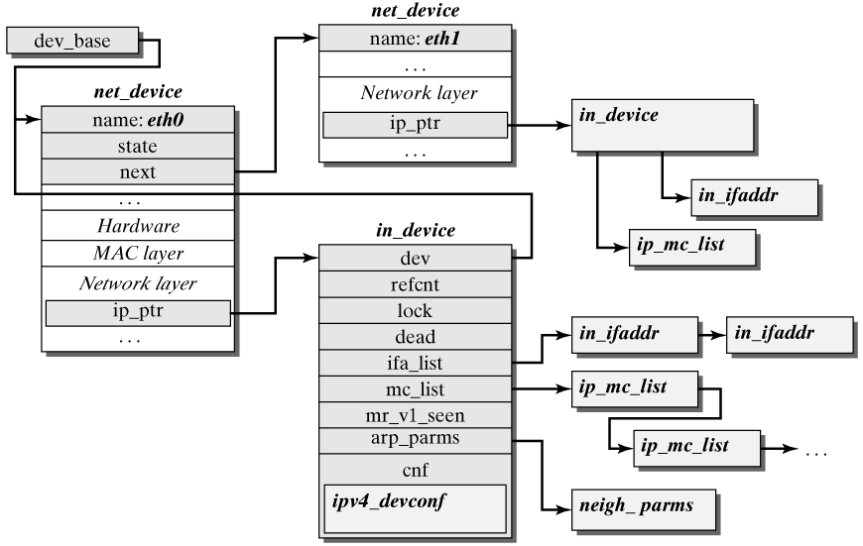

对于路由器的IP Instance，每个物理网络适配器除了有个net_device结构，还有一个in_device结构，它们之间的联系如上图所示。
in_device结构如下：
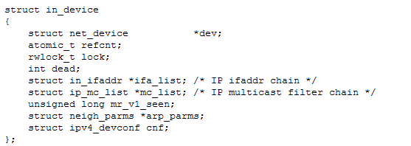
- dev points to the net_device structure of the network device configured for the Internet Protocol.
- refcnt stores the number of references to this structure, or the number of instances currently used by this IP network device.
- lock is used to protect against errors caused by parallel manipulation in the in_device structure.
- dead shows whether this IP network device is still valid.
- ifa_list points to a list of in_ifaddr structures, which stores the IP addresses of this IP network device. This is a list, because Linux lets you allocate more than one IP address to a network device (alias function). In addition to the IP address (ifa_address), the in_ifaddr structure stores other parameters (e.g., the subnet mask (ifa_mask), the broadcast address (ifa_address), etc.)：
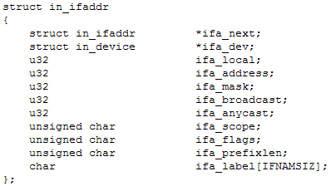
- mc_list is a list consisting of ip_mc_list structures. Each element in this list stores information for an IP multicast group to which the IP instance is currently subscribed, and receives it over the current network device.
- mr_vl_seen is used by IGMP.
- arp_parms points to a structure of the type neigh_parms, which stores the most important parameters of the ARP protocol.
- cnf points to an ipv4_devconf structure, which stores important settings for the IP instance for current network device. The ipc4_devconf data structure can be used to activate or deactivate various properties of the IP instance for an IP network device.
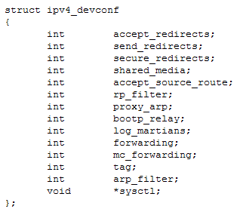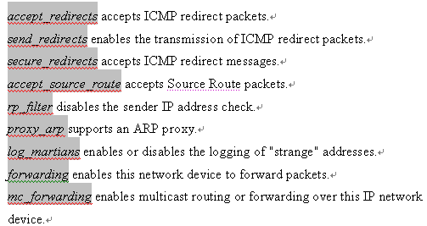

7.3 IP Options
IP Header必须是4字节的倍数。IP Header中的4位首部长度，是指该IP Header有多少个4字节。

7.3.1 Introduction of IP Options
一个IP Header中可以包含1个或多个Option，每一项Option的长度可能是不同的，但每个Option的第一个字节具有如下格式：
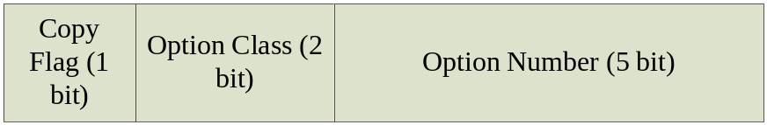
The (1-bit) copy flag is required for packet fragmentation. If a packet has to be fragmented, then this bit states whether this packet option has to appear in all fragments or may be set in the first fragment only. The option class is represented by 2 bits. The (5-bit) option number shows the length of a packet option implicitly.
下面主要介绍一些常用的IP Option：
1) Loose Source Routing
该选项规定IP包在网络传输中必须访问的所有路由器。其格式是这样的：
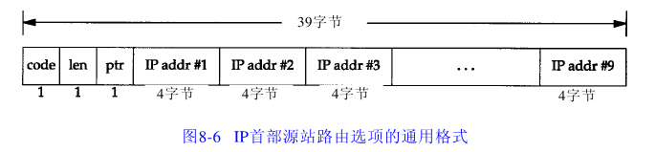
说明：第三个字节开始的Pointer字段作用类似于指针，通过它，可以在Route Data字段中找到下一个router的IP地址。
Cites：If the pointer points to a byte not belonging to this option according to the length byte, then the packet can be sent over an arbitrary path to the actual destination address(根据路由表信息). In contrast, if the packet has reached the address specified in the destination address field, yet the pointer still points to another valid address, then the destination address field is overwritten with this address. The pointer is incremented by the length of an IP address, 4 bytes.
2) Strict Source Routing
格式如下：
它和Loose Source Routing不同，到达中间的router后会检查当前router的IP地址是否和Route Data List中的相符，如果不符，就会发送一个ICMP给Sender，并Drop该包。而Loose Source Routing则不做这样的检查：
下面的代码片段从ip_forward()函数中截取的，当收到Packet时，根据路由选择，会断定是转发该包还是交予上层协议处理，如果是转发它则会调用ip_forward()，这个在7.2.1中有详细介绍。
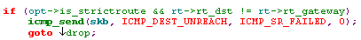
Cites: The Strict Source Routing option differs in only one point from the Loose Source Routing option: The packet may pass exactly those routers specified in the Route Data list. If a packet arrives in a router not explicitly present in this list, then an ICMP message has to be generated and returned to the sender.
3) Record Route:
其格式如下：
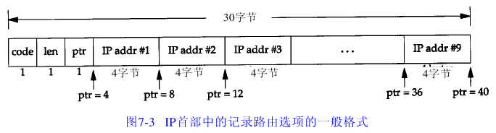
code字段为00000111。从图中可以看出，最多只能记录9个IP地址(4字节)。这是一个缺点。
Cites: The Record Route option can be used to register the addresses of all intermediate systems an IP packet will pass on its way to the destination. The third byte includes a pointer to the field that is to accept the next address. Each Internet node adds its address in a field specially provided for this purpose and increases the pointer by four bytes (corresponding to the length of an IP address). If no more space is available, then the IP packet is forwarded without storing the address(并不Drop它). In this case, an ICMP message can be returned to the sender.
In contrast to the two previous packet options (i.e., Loose Source Routing and Strict Source Routing), this option appears only in the first fragment, if an IP packet has to be fragmented. 这样在Receiver端将这些fragments组装后，其IP Header的Options中就有了相应的Route Data。

4) End of Option List && No Operation
这两种Option都只占一个字节，它们都是作为占位标识符的。End of Option List表示Options List的结束标识；而每两个Option之间要用No Operation隔开：
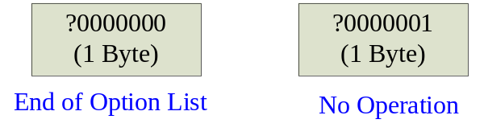
另外，还有2种Option，一个是Security，一般用于军方网络；另一个是Internet Timestamp，这里略。可以参考《The Linux® Networking Architecture: Design and Implementation of Network》中的14.3.1

7.3.2 IP Options in the IP Layer
首先介绍Linux内核表示Options的数据结构：struct ip_options。ip_options结构中可以存储Options List，它由__data和optlen字段指定。一般情况下Socket在其ip_options结构中存储Options List，该Socket下的所有欲发送的Packet共享该Options List；而对于接受到的packet，要解析IP Header，抽取出相应的Options List，并将相关字段填充到sk_buff的ip_options结构中(调用ip_options_compile()完成)。
注：每个sk_buff结构中有个char cb[48]字段，这48字节就被分成2个部分，即ip_options结构和1字节的flags。事实上这48个字节是控制字段，每层的协议实例均可使用它们。对于IP协议来说，它是inet_skb_parm结构，而对于TCP协议来说，它是struct tcp_skb_cb结构。
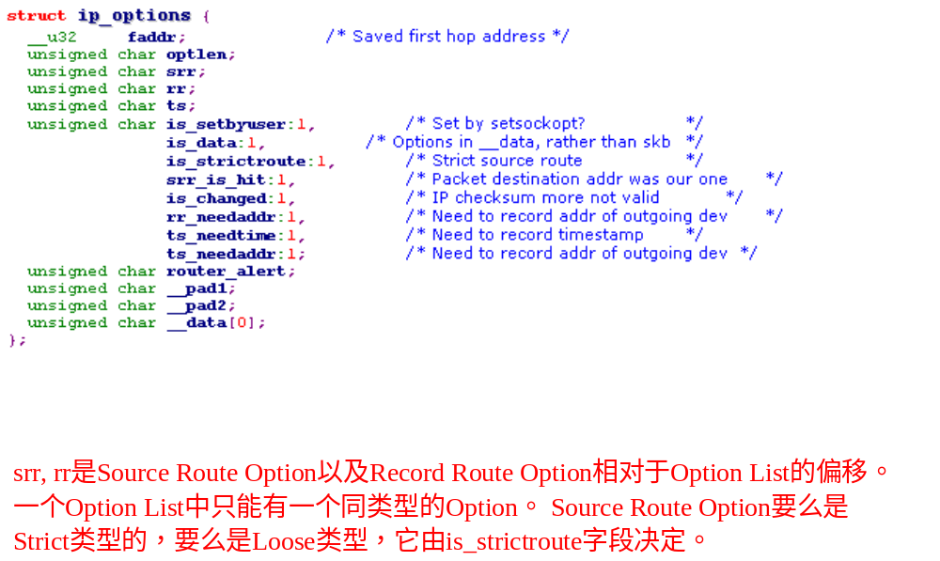
1) Receive Packet
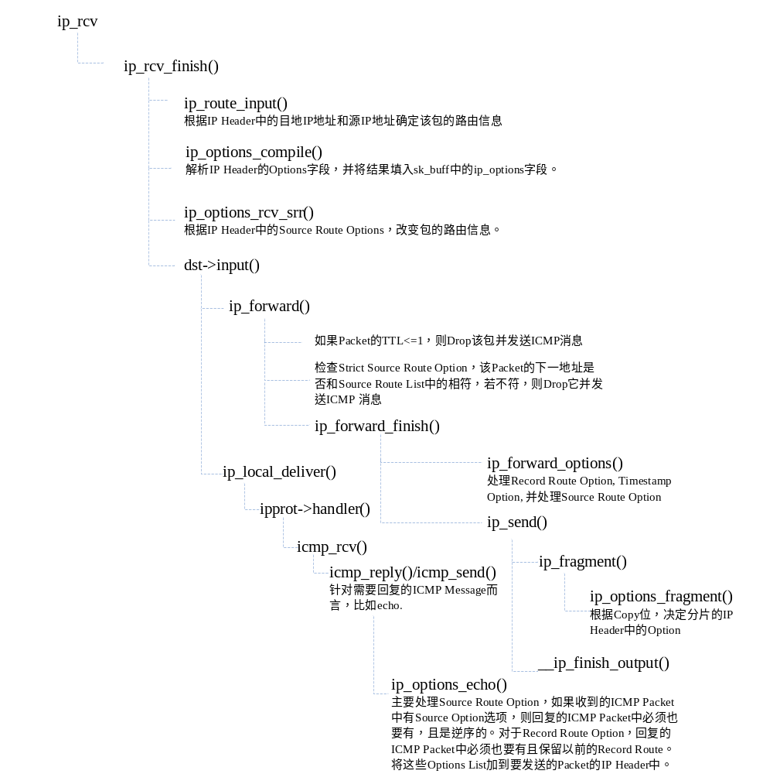
2) Sending Packet时。
这有三种情况，①是发送ACK/ SYN Packet时，它们都没有对应的Payload，不过各层的Header是必须有的。这时它们会调用ip_build_and_send_pkt()。② 是高层协议比如TCP/UDP等发送Packet到IP层时，这时会调用ip_queue_xmit(),详见7.2.2 ③发送ICMP message，通过icmp_send()或icmp_reply().
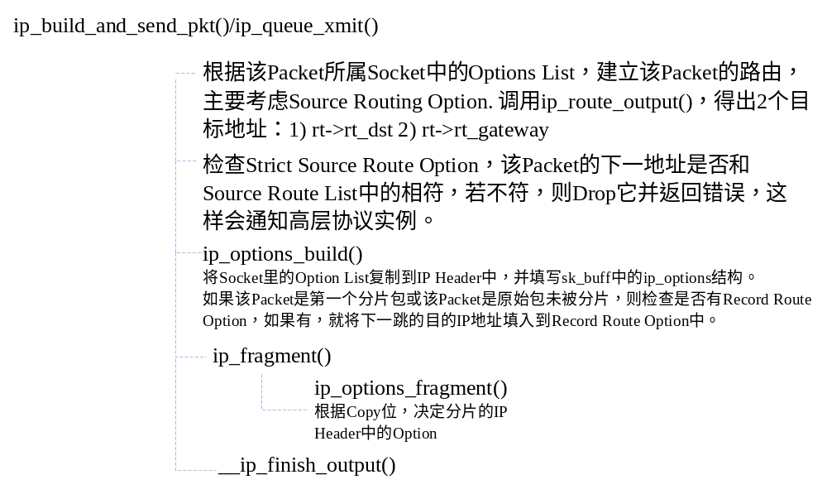
举例：
Case1： Strict Source Route(以下涉及的地址均为IP地址)
假设主机S发送Packet到主机D，我们在该IP Header中设定了Strict Source Route，(R1, R2, R3)，下面看看该Packet的传输过程：
1) 主机S调用ip_rout_output()，它首先根据目标地址D查看本机路由表，将结果存入rt->rt_gateway中，然后将Source Route Option的第一表项R1放入rt->rt_dst中。接着比较两者的值，如果不等，则Drop该包，并返回错误通知高层协议实例。注：这个过程发生在ip_queue_xmit()中：
2) 将rt->rt_dst的值放入IP Header的目的IP地址字段中，将真正的目的地址D放入Source Route的最后一个表项，然后将rt->rt_gateway的值存入Record Route Option中，接着将该包发送出去：
此时，IP Header中的的相关字段如下：
Source IP Address：S；
Destination IP Address：R1
Source Route Option：(#R2, R3, D)
Record Route: (R1)
注：它会根据rt->rt_gateway找到对应的Mac地址(ARP协议)，将它作为帧头的目的Mac地址。源Mac地址事实上是在发送该包的net_device结构的dev_addr[]字段中。
3) 当数据包传到R1时，R1首先调用ip_route_input()，它会判断本机是否为目的地址(接收端的IP地址与IP头中的目的IP地址比较)，若不是将skb->dst->input设置为ip_forward()，并根据目的地址选择路由；若是则skb->dst->input设置为ip_local_deliver()。目前是将skb->dst->input设置为ip_local_deliver()。接着考虑Source Route Option, 调用ip_options_rcv_srr()，如果本机是目的地址，且SR Option中的ptr不大于路径的长度，则取指针所指的R2为新的目的地址，并将本机地址R1放到ptr所指的表项中，接着ptr加4，指向下一个表项。根据这新的目的地址重新调用ip_route_input()，这时skb->dst->input设置为ip_forward()，且根据新的目的地址R2得出新的路由，存入rt->rt_gateway中。
4) 调用ip_forward()，比较选择出来的路由信息rt->rt_gateway是否等于R2，若不等，则Drop该Packet，并向S发送ICMP消息(ICMP_DEST_UNREACH),接着处理RR Option，然后发送它。
注：真正发送Packet之前，IP Header的Destination IP Address会被设置为rt->rt_gateway，在这之前，不会修改它。所以在向S发送ICMP消息(ICMP_DEST_UNREACH)时，它的源/目的地址分别为：(R1, S).
此时，IP Header中的的相关字段如下：
Source IP Address：S；
Destination IP Address：R2
Source Route Option：(R1, #R3, D)
Record Route: (R1，R2)
注：它会根据rt->rt_gateway找到对应的Mac地址(ARP协议)，将它作为帧头的目的Mac地址。源Mac地址事实上是在发送该包的net_device结构的dev_addr[]字段中
5) 对于R2，也是做同样的处理，IP Header中的的相关字段如下：
Source IP Address：S；
Destination IP Address：R3
Source Route Option：(R1, R2, #D)
Record Route: (R1，R2，R3)
注：它会根据rt->rt_gateway找到对应的Mac地址(ARP协议)，将它作为帧头的目的Mac地址。源Mac地址事实上是在发送该包的net_device结构的dev_addr[]字段中
6) 对于R3，也是做同样的处理，IP Header中的的相关字段如下：
Source IP Address：S；
Destination IP Address：D
Source Route Option：(R1, R2, R3#)
Record Route: (R1，R2，R3, D)
注：它会根据rt->rt_gateway找到对应的Mac地址(ARP协议)，将它作为帧头的目的Mac地址。源Mac地址事实上是在发送该包的net_device结构的dev_addr[]字段中
7) 当包传入D时，同样它会调用ip_route_input()，它会判断本机是否为目的地址(接受端的IP地址与IP头中的目的IP地址比较)，会将skb->dst->input设置为ip_local_deliver()，然后处理SR Option，它发现ptr大于路径的长度，这时就不做任何处理了，接着会调用ip_local_deliver()将包传递给上层协议实例处理。此时它的IP Header如下：
Source IP Address：S；
Destination IP Address：D
Source Route Option：(R1, R2, R3#)
Record Route: (R1，R2，R3, D)
Case2： Loose Source Route(以下涉及的地址均为IP地址)
假设主机S发送Packet到主机D，我们在该IP Header中设定了Loose Source Route，(R1)，该Packet的传输路径为（I1，I2，R1，I3，D），下面看看该Packet的传输过程：
1) 主机S调用ip_rout_output()，它首先根据目标地址D查看本机路由表，将结果存入rt->rt_gateway中，这时是I1，然后将Source Route Option的第一表项R1放入rt->rt_dst中。
2) 将rt->rt_dst的值放入IP Header的目的IP地址字段中，将真正的目的地址D放入Source Route的最后一个表项，接着将该包发送出去：
Source IP Address：S；
Destination IP Address：R1
Source Route Option：(#D)
Record Route: (I1)
注：它会根据rt->rt_gateway(I1)找到对应的Mac地址(ARP协议)，将它作为帧头的目的Mac地址。源Mac地址事实上是在发送该包的net_device结构的dev_addr[]字段中
3) I1此时收到了，则通过调用ip_route_input()将skb->dst->input设为ip_forward，且根据IP头中的目的地址，找到下个路由I2，这里会把rt->rt_gateway设为I2，接着考虑Source Route Option, 调用ip_options_rcv_srr()，这时它什么都不干，此时Source Route Option，rt->rt_gateway和目标IP地址都没改，然后调用ip_forward, 处理Record Route后，将该Packet发送出去，这时IP Header的内容如下：
Source IP Address：S；
Destination IP Address：R1
Source Route Option：(#D)
Record Route: (I1，I2)
注：它会根据rt->rt_gateway(I2)找到对应的Mac地址(ARP协议)，将它作为帧头的目的Mac地址。源Mac地址事实上是在发送该包的net_device结构的dev_addr[]字段中
4) I2收到后，其处理过程和3)一样，它得到的路由地址为R1，存入 rt->rt_gateway中。这时IP Header的内容如下：
Source IP Address：S；
Destination IP Address：R1
Source Route Option：(#D)
Record Route: (I1，I2，R1)
注：它会根据rt->rt_gateway（R1）找到对应的Mac地址(ARP协议)，将它作为帧头的目的Mac地址。源Mac地址事实上是在发送该包的net_device结构的dev_addr[]字段中
5) R1收到后，R1首先调用ip_route_input()，它会判断本机是否为目的地址(接受端的IP地址与IP头中的目的IP地址比较)，若不是将skb->dst->input设置为ip_forward()，并根据目的地址选择路由；若是则skb->dst->input设置为ip_local_deliver()。目前是将skb->dst->input设置为ip_local_deliver()。接着考虑Source Route Option, 调用ip_options_rcv_srr()，如果本机是目的地址，且SR Option中的ptr不大于路径的长度，则取指针所指的D为新的目的地址，并将本机地址R1放到ptr所指的表项中，接着ptr加4，指向下一个表项。根据这新的目的地址重新调用ip_route_input()，这时skb->dst->input设置为ip_forward()，且根据新的目的地址D得出新的路由I3，存入rt->rt_gateway中。接着处理Record Route Option，接着发送该Packet。这时IP Header的内容如下：
Source IP Address：S；
Destination IP Address：D
Source Route Option：(R1#)
Record Route: (I1，I2，R1, I3)
注：它会根据rt->rt_gateway(I3)找到对应的Mac地址(ARP协议)，将它作为帧头的目的Mac地址。源Mac地址事实上是在发送该包的net_device结构的dev_addr[]字段中
- I3收到后，其处理过程和3)一样，它得到的路由地址为D，存入 rt->rt_gateway中。这时IP Header的内容如下：
Source IP Address：S；
Destination IP Address：D
Source Route Option：(R1#)
Record Route: (I1，I2，R1, I3，D)
注：它会根据rt->rt_gateway(D)找到对应的Mac地址(ARP协议)，将它作为帧头的目的Mac地址。源Mac地址事实上是在发送该包的net_device结构的dev_addr[]字段中
7) 当包传入D时，同样它会调用ip_route_input()，它会判断本机是否为目的地址(接受端的IP地址与IP头中的目的IP地址比较)，会将skb->dst->input设置为ip_local_deliver()，然后处理SR Option，它发现ptr大于路径的长度，这时就不做任何处理了，接着会调用ip_local_deliver()将包传递给上层协议实例处理。此时它的IP Header如下：
Source IP Address：S；
Destination IP Address：D
Source Route Option：(R1#)
Record Route: (I1，I2，R1, I3，D)

Source Route Handler：
• 发送主机从应用程序接收源站路由清单，将第1个表项去掉（它是数据报的最终目的地
址），将剩余的项移到1个项中，并将原来的目的地址作为清单的最后一项。指针仍然指向清单的第1项（即，指针的值为4）。
• 每个处理数据报的路由器检查其是否为数据报的最终地址(本机IP等于IP Header中的目的地址)。如果不是，则正常转发数据报（在这种情况下，必须指明宽松源站选路，否则就不能接收到该数据报）。
• 如果该路由器是最终目的(本机IP等于IP Header中的目的地址)，且指针不大于路径的长度，那么(1)由p t r所指定的清单中的下一个地址就是数据报的最终目的地址；(2)由外出接口(outgoing interface)相对应的I P地址取代刚才使用的源地址；(3)指针加4。
在处理Record Route的时候，永远都是将rt->rt_gateway存入Record Route Option中。

7.4 ICMP
ICMP sends and receives special IP packets representing error or information messages. ICMP Packet是一种特殊的IP 数据包，其格式如下，其中The 8-bit Type field in the ICMP part specifies the type of ICMP message. The Code field specifies the values an ICMP message can take. 16位校验和覆盖了从Type字段开始的字段，即该校验和整个覆盖了IP被看做有效负荷的那个部分。(IP Header的校验和在Header Checksum中。)
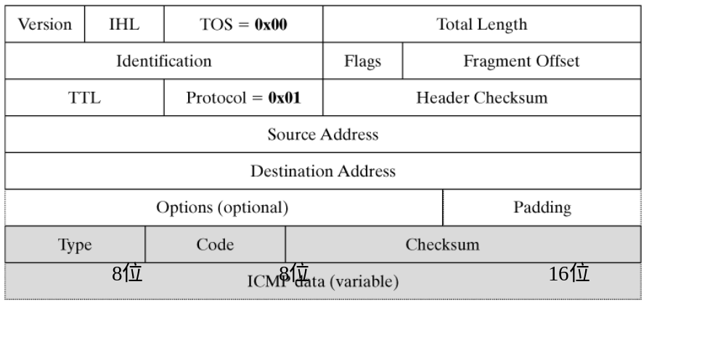
RFC792定义了11种ICMP Message，Linux支持其中的部分：
Type | Description | Support in Linux
Destination Unreachable | The destination address cannot be reached. | √
Time Exceeded | A packet was discarded, because its TTL has expired. | √
Parameter Problem | Unknown or false options. | √
Source Quench | Informs the sender that IP packets were lost to overload. | ×
Redirect | Enables path optimization. | ×
Echo and Echo Reply | The data sent to the destination address is returned in a reply. | √
Timestamp and Timestamp Reply | The timestamp sent to the destination address is used-to reply with the timestamp of the destination address. | √
Information Request und Information Reply | Request/reply used to find the network a computer connects to. | ×

7.4.1 Introduction of ICMP Message
1) Destination Unreachable
除去IP Header，这类的ICMP Message格式如下：
Type-0x03 | Code (8 bit) | Checksum (16 bit)
Unused
IP Header + 64位原始数据(导致该ICMP消息的IP Header以及前64位数据)
- Code = 0x00 (Network Unreachable): The network of an IP packet's receiver is not reachable. This can happen, for example, if the distance to the receiver's network is set to infinite in the routing table of a router.
[Linux]:发送方一般是router.
- Code = 0x01 (Host Unreachable): The desired destination computer in the specified network cannot be reached.
[Linux]:发送方一般是router.
- Code = 0x02 (Protocol Unreachable): This message can be generated if another protocol listens to the destination port specified in the TCP packet header. The message can be sent both by a router and by an end system.
[Linux]:发送方一般是end system.
- Code = 0x03 (Port Unreachable): The port address of the receiver specified in the TCP packet header is not reachable. The end system is "reachable" in this case, too, so both a router and an end system can generate this message.
[Linux]:发送方一般是end system.，IP Instance处理后将Packet移交上层，这时会查看源端口号进行过滤。如果当前没有进程使用该目的端口号，则丢弃该Packet并产生一个此ICMP Message.
- Code = 0x04 (Fragmentation Needed): This ICMP packet can be sent if an IP packet has to be fragmented in a router, but the Don't-Fragment flag is set in the packet header, so that the packet may not be fragmented. In this case, the router has to discard the IP packet.
[Linux]:发送方可以是router或是end system，router在转发时，end system在发送数据报时也会做相应的检查。
- Code = 0x05 (Source Route Failed): If the IP packet option Source Routing is set and an error occurs, then this ICMP message is returned to the sender.
[Linux]:发送方一般是router，这部分详见7.3.2
2) Time Exceeded
除去IP Header，这类的ICMP Message格式如下：
Type-0x0B | Code (8 bit) | Checksum (16 bit)
Unused
IP Header + 64位原始数据(导致该ICMP消息的IP Header以及前64位数据)
- Code = 0x00: A router sends this message if it discarded a packet because its TTL had expired.
- Code = 0x01: An end system sends a message with this code if it was unable to reassemble a fragmented IP message correctly within a certain time, because fragments were missing.
3) Parameter Problem
除去IP Header，这类的ICMP Message格式如下：
Type-0x0C | Code =0x00(8 bit) | Checksum (16 bit)
Pointer（8 bit） | unused
IP Header + 64位原始数据(导致该ICMP消息的IP Header以及前64位数据)
注：The pointer field points to the octet in the original IP packet header where the problem occurred while the packet was being processed.
If an error due to an invalid parameter in the IP header occurs while an IP packet is being handled in an intermediate node or end system, then this IP packet is discarded. 在Linux中只是在处理IP Option的时候，如果发现Option有错误会向Send发送这类ICMP Message.
An end system or intermediate system can send such message, 因为它们在接受到一个Packet后都可能需要解析IP Option，多半在ip_options_compile()中。
4) Echo and Echo Reply
除去IP Header，这类的ICMP Message格式如下:
Type | Code =0x00(8 bit) | Checksum (16 bit)
Identifier(16 bit) |  | Sequence Number（8 bit）
Data…
Echo and Echo Reply messages are normally used to verify the existence of an end system or intermediate system. To this end, an Echo message is sent to the desired system. The ICMP implementation in the receiver has to respond to this Echo request by sending an Echo Reply message. Echo and Echo Reply messages differ only in the Type field: 0x08 specifies an Echo message and 0x00 specifies an Echo Reply message. 另外要注意的是，Echo Request和Echo Reply它们两者除了Type和IP Header的源/目的地址不一样以外，其他都一样，特别是Identitier，sequence number和Data字段必须相同。
5) Timestamp and Timestamp Reply
除去IP Header，这类的ICMP Message格式如下:
Type | Code =0x00(8 bit) | Checksum (16 bit)
Identifier(16 bit) |  | Sequence Number（8 bit）
Originate Timestamp
Receive Timestamp
Transmit Timestamp
它和Echo and Echo Reply类似，The Type field is used to distinguish between Timestamp and Timestamp Reply: A value of 0x00 specifies a Timestamp message, and 0x0E denotes a Timestamp Reply message. The Originate Timestamp field defines the time when the transmitted ICMP message was last "touched" by the sender. Similarly, there is a Receive Timestamp specifying the time that the message arrived in the receiver. Transmit Timestamp stores the time at which the Timestamp Reply message was sent.
6) Redirect
除去IP Header，这类的ICMP Message格式如下:
Type=0x05 | Code (8 bit) | Checksum (16 bit)
Router IP Address
IP Header + 64位原始数据(导致该ICMP消息的IP Header以及前64位数据)
This ICMP message type is designed to optimize routing through the Internet.举个例子， Assume that a router R1, receives an IP packet from sending end system S to the receiver E. Based on a corresponding entry in the routing table of R1, this packet is forwarded to router R2. However, if R2 and S are in the same network (which can be determined based on the sender address), this route can be optimized by sending packets from S to receiver E directly to router R2 over R1, without detour. In this case, router R1 would send a Redirect message to end system S to announce that packets to receiver E will be sent directly to R2 in the future. Consequently, the field Router IP Address would contain the IP address of R2。R1这时会向Sender S发送ICMP Message，其IP Header和相应的数据如下：
Source IP Address = E |  | Destination IP Address = S
Type=0x05 | Code (8 bit) |  | Checksum (16 bit)
R2
IP Header + 64位原始数据(导致该ICMP消息的IP Header以及前64位数据)
当S收到该ICMP Message时，会调用icmp_redirect()它的本地路由表，将发送到E的IP数据包转发到R2。

7.4.2 ICMP in Linux Kernel
Ping程序发送ICMP Message是独立Linux内核中的ICMP实现的，这里不做详细讨论。Linux内核中的ICMP实现主要分为:1）发送ICMP Message，2) 处理收到的ICMP Message.
1） 发送ICMP Message
只要不是Reply ICMP Message，Linux的ICMP实现中用于发送ICMP Message都是利用icmp_send(). This function gets all data from an ICMP message as call parameters, which means that it can send any ICMP type:
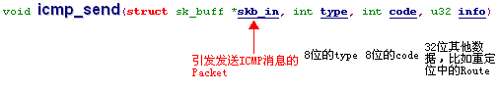
除此之外，icmp_send()还要避免如下情况：
1) If the IP packet that initiated an ICMP message was an ICMP error message, then a reply to this error message could cause an infinite cycle of ICMP messages.
2) 引起该ICMP Message的IP Packet的目的地址是广播地址或多播地址的IP数据报。
3) 引起该ICMP Message的Packet是链路层的多播或广播。
4) If an IP packet was fragmented, then an ICMP message is sent for the first fragment only to avoid loading the network unnecessarily with redundant packets.（只对第一片IP Packet发送ICMP Message）
5) 引起该ICMP Message的IP Packet的源地址不是单个主机。这就是说，源地址不能为零地址、环回地址、广播地址或多播地址。
对于上述情况，icmp_send()都会返回而不发送相应的ICMP Message。
icmp_send()的逻辑很简单，它的参数中包括了组装ICMP Packet的所有信息，它首先检查引发ICMP Message的IP Packet是否满足上述5种情况，如果满足其中之一，则返回。接着检查IP Header中是否有Options，特别是Record Route以及Source Route，如果有RR，则将RR Option中的所有条目都拷贝到新的IP Header中；如果是Source Route，则将它们倒序拷贝到新的IP Header中。接着查询路由，这时它的目的地址是IP Packet的源地址，源地址是IP Packet的目的地址(这时要考虑Source Route的情况)，路由查询完毕后，调用ip_build_xmit()将该组装好的ICMP Packet发送出去, 发送出去新IP Header的目的地址是原Packet的源地址(或是新Source Route Option中的第一个目的地址，还记得之前已经倒序拷贝了吗？)，新IP Header源地址是原Packet的目的地址：
发送的Packet的IP Header的protocol字段设置为：IPPROTO_ICMP
2） 处理incoming ICMP Message
和所有收到的IP Packet一样，首先它会调用ip_rcv()去处理，接着如果该IP Packet是发送给本机的，则会调用ip_local_deliver(),而它会根据IP Header中的protocol字段调用相应的协议实例继续处理，这里protocol字段是“IPPROTO_ICMP”，这时会调用icmp_rcv()。
icmp_rcv()首先会检查包的长度，计算校验和，如果出现了错误，则Drop该包。内核将每种类型的ICMP Message处理函数封装在icmp_pointers散列表中：
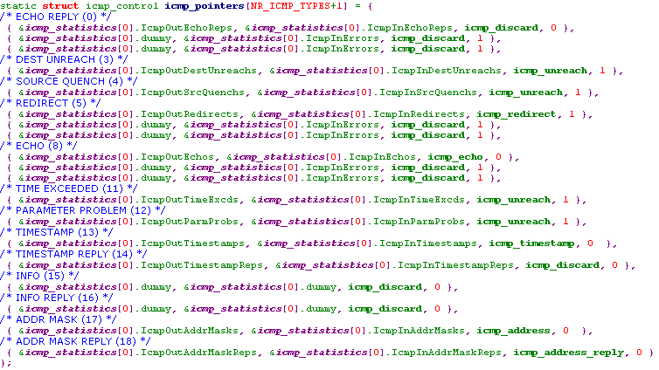
接着会根据查询该散列表(根据type字段)，调用相应的Handler。
- icmp_reply()
The function icmp_reply() is generally used to reply to ICMP request packets. Before a reply is sent, the internal statistics variables are updated first; then the TOS field is taken from Request, and the IP addresses of the sender and the receiver are swapped.(同样要考虑Source Route Option) Next, the packet is returned to the sender, including the payload passed as argument (corresponding to the ICMP reply packet). icmp_reply() is used by two functions, icmp_echo() and icmp_times(), to reply to Echo Request and Timestamp Request, respectively.
- icmp_redirect()
This function updates the routing table when an end system receives an ICMP message of the type Redirect.
- icmp_unreach()
This function handles three ICMP message types: Destination Unreachable, Source Quench, and Time Exceeded. After a number of tests for packet validity, this function passes the error message to the service of the next higher layer belonging to the initiating packet. In the case of Source Quench, the receiving computer is expected to reduce its sending rate, which will be handled by the protocol in the transport layer above IP。
注：Linux并不支持Source Quench，它并不发送Source Quench的ICMP消息，如果收到Source Quench的ICMP消息时，只是打印一条Message在控制台，。
- icmp_echo()/icmp_timestamp()
A new ICMP packet has to be sent to handle ICMP messages of the types Echo Request and Timestamp Request. The basic function icmp_reply() is used in either case. For icmp_echo(), only the ICMP type is changed, to ICMP_ECHOREPLY, then the payload part is copied from the Echo packet, and finally icmp_reply() returns the packet to the sender;
The function icmp_timestamp() responds to incoming Timestamp requests. Initially, it checks the length of packets previously received and finds out the current time. The payload is removed from the original ICMP packet and put into the reply packet, and the time is added to the Receive Timestamp and Transmit Timestamp fields. This means that the two time values in Receive Timestamp and Transmit Timestamp are always identical. Once the packet type has been changed to ICMP_TIMESTAMPREPLY, the function icmp_reply() returns the packet.
注：ICMP Address Mask Request用于无盘系统在引导过程中获取自己的子网掩码，通过发送Request，然后等待应答的Packet而得到Mask。Linux本身并不支持ICMP Address Mask Request/Reply, 当收到ICMP Address Mask Request，它调用icmp_address()，这是个空函数，什么都不干；当它收到ICMP Address Mask Reply时， it checks this packet for correct network mask (and complains by outputting a kernel message if it finds an inconsistency).

当链路层或是IP层处理收到的Packet时，如果Packet的内容或是其他原因需要丢弃该Packet时，一般不会通知Sender，当然也有例外(利用ICMP Message)。通常Sender的高层协议实例(TCP)都会处理这些丢Packet的情况，可以利用时间窗口或者ICMP Message。

